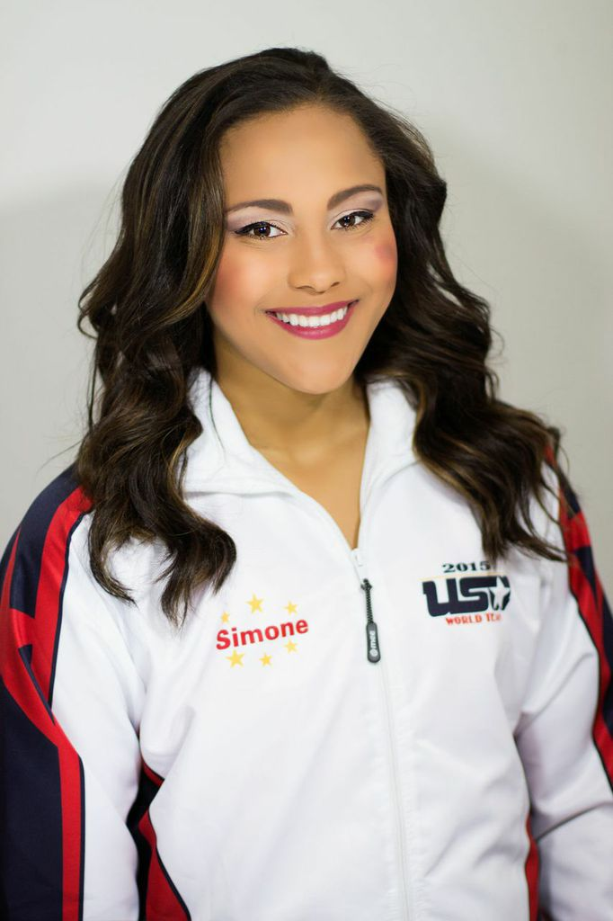
Simone Esters Twirling Resume
NBTA – National Baton Twirling Association Accomplishments:
Miss Majorette of America – 2012 (Pre-Teen), 2014 (Junior)
Top Five in the Nation in the Miss Majorette of America Pageant – 2008, 2009
(Juvenile), 2010, 2011, 2012* (Pre-Teen), 2013, 2014* (Junior), 2017
(Teenage)
Grand National Twirling Champion – 2012 (Pre-Teen)
Top Six in the Nation in Grand National Majorette Finals – 2006 (Tiny Tot), 2008,
2009 (Juvenile), 2011, 2012* (Pre-Teen), 2013, 2014, 2015 (Junior) 2016,
2017 (Senior)
NBTA World Team Member – 2012 Solo, Strut, Two-Baton, and Duet (Pre-Teen), 2015 Strut and Two-Baton (Junior)
NBTA World Duet Gold Medalist – 2012 (Pre-Teen)
NBTA World Solo Silver Medalist – 2012 (Pre-Teen)
NBTA World Strut Silver Medalist – 2012 (Pre-Teen), 2015 (Junior)
NBTA World Two-Baton Bronze Medalist – 2012 (Pre-Teen), 2015 (Junior)
NBTA Collegiate WOW Award Winner – 2017
NBTA Collegiate Down Field Competition – 3rd Place
National Strut Champion – 2012 (Pre-Teen)
Top Five in the Nation in the Twirling Finals – 2008, 2009 (Juvenile), 2010, 2011,
2012 (Pre-Teen), 2013, 2014, 2015(Junior), 2017 (Senior)
Top Five in the Nation in the Strutting Finals – 2008, 2009 (Juvenile), 2010, 2011, 2012 (Pre-Teen), 2013, 2014, 2015
(Junior), 2017 (Senior)
Top Five in the Nation in the Two-Baton Finals – 2011, 2012 (Pre-Teen), 2014, 2015 (Junior), 2017 (Senior)
Top Five in the Nation in Rhythmic Twirl – 2010 (Pre-Teen), 2014, 2015 (Junior)
National Duet Champions – 2007, 2009 (Juvenile), 2010, 2011, 2012 (Pre-Teen), 2013 (Junior)
National Show Twirl Champion – 2007 (Juvenile)
World-Open Two-Baton Champion – Age 9 (2009), Age 10 (2010), Age 12 (2012)
World-Open Strut Champion – Age 10 (2010), Age 12 (2012), Age 13 (2013), Age 14 (2014), Age 15 (2015), Age 16
(2016), Age 17 (2017)
World-Open Three-Baton Champion – Age 14 (2014), Age 15 (2015), Age 16 (2016)
World-Open Duet Champions – 2008, 2009 (Juvenile), 2012 (Pre-Teen), 2013 (Junior)
Miss Majorette of Pennsylvania – 2009 (Juvenile) 2010, 2011, 2012 (Pre-Teen), 2013, 2014 (Junior), 2016, 2017 (Teenage)
PA State Queen – 2008, 2009 (Juvenile), 2011, 2012 (Pre-Teen), 2013, 2014 (Junior)
PA State Solo Champion – 2009 (Juvenile), 2010, 2011, 2012 (Pre-Teen), 2013, 2014 (Junior)
PA State Strut Champion – 2009 (Juvenile), 2011, 2012 (Pre-Teen), 2013, 2014 (Junior)
PA State Two-Baton Champion – 2008, 2009 (Juvenile), 2010, 2011, 2012 (Pre-Teen), 2013, 2014 (Junior)
PA State Three-Baton Champion – 2014 (Junior)
PA State Duet Champions – 2008 (Juvenile), 2010 (Pre-Teen)
Miss Majorette of the North Atlantic – 2008, 2009 (Juvenile)
North Atlantic Regional Modeling Champion – 2008, 2009 (Juvenile), 2011 (Pre-Teen), 2013, 2014 (Junior)
North Atlantic Solo Champion – 2008, 2009 (Juvenile), 2010, 2011, 2012 (Pre-Teen), 2013, 2014, 2015 (Junior), 2017
(Senior)
North Atlantic Strut Champion – 2008, 2009 (Juvenile), 2010, 2011, 2012 (Pre-Teen), 2014, 2015 (Junior), 2017 (Senior)
North Atlantic Two-Baton Champion – 2008, 2009 (Juvenile), 2011, 2012 (Pre-Teen), 2013, 2014, 2015 (Junior)
North Atlantic Three-Baton Champion – 2010 (Pre-Teen), 2013, 2014, 2015 (Junior)
North Atlantic Rhythmic Champion – 2009 (Juvenile), 2010, 2011, 2012 (Pre-Teen), 2014 (Junior)
North Atlantic Duet Champions – 2008 (Juvenile), 2012 (Pre-Teen)

USTA – United States Twirling Association & WBTF – World Baton Twirling Association Accomplishments:
USTA International Cup Team Member – 2013 Elite Solo and Elite Two-Baton (Junior), 2015 Elite Solo, Elite Two-Baton, and Elite Three-Baton (Junior), Team Intrepide
USTA World Team Member – 2014 Team Intrepid
WBTF World Bronze Medalist – Team Intrepid (2014)
WBTF Finalist at International Cup – 2013, 4th place Elite Solo & 8th place Elite Two-Baton (Junior), 2015, 5th place Elite Solo, 6th place Elite Two-Baton (Junior), & 8th place Elite Three-Baton (Junior)
USTA National Twirling Champion – 2013 (Junior)
USTA National Finalist – Solo & Three-Baton (2013), Three-Baton (2014), Solo (2015)
USTA National Solo Champion – Age 13 (2012), Age 15 (2014)
USTA North East Regional Solo Champion – Junior (2015)
USTA North East Regional Two-Baton Champion – Junior (2014, 2015)
USTA North East Regional Three-Baton Champion – Junior (2014, 2015)

IBTF Grand Prix Accomplishments:
USTA Grand Prix Team Member – 2015 Elite Two-Baton (Junior) and Team Intrepid
NBTA Grand Prix Team Member – 2015 Elite Solo (Junior)
IBTF Bronze Medalist – Team Intrepid (2015)
IBTF Finalist at Grand Prix – 2015, 8th place Elite Solo (Junior)

Congressional Cup Accomplishments:
Congressional Cup Invitee – 2014, 2015, 2016
Congressional Cup Finalist – 2014 (5th place), 2015 (3rd Place), 2016 (2nd Place)
Congressional Cup Tournament Solo Finalist – 2008, 2009 (Juvenile), 2010, 2011, 2012 (Pre-Teen), 2013,
2014, 2015 (Junior)

Twirl Mania Accomplishments:
Miss Twirl Mania Gold – 2013 (Pre-Teen)
Miss Twirl Mania Elite – 2014 (Junior)
Twirl Mania Elite Twirl-Off Champion – 2015 (Senior)
Twirl Mania Elite Solo Champion – 2012 (Junior)
Twirl Mania Gold Top Five Finalist – 2012 (Pre-Teen), 2013*, 2014, 2015 (Junior)
Miss Twirl Mania Elite Top Five Finalist – 2010 (Pre-Teen), 2012, 2013, 2014*, 2015 (Junior)
Twirl Mania Elite Solo Finalist – 2010, 2012, 2015
Twirl Mania Elite Two-Baton Finalist – 2010, 2012, 2014
Twirl Mania Elite Strut Finalist – Finalist 2010, 2012, 2015
Twirl Mania Duet Champions – 2008 (Juvenile), 2012 (Pre-Teen)

TU – Twirling Unlimited Accomplishments:
TU International World Majorette – 2007 (Tiny Tot), 2010 (Juvenile)
TU International Solo Champion – 2007 (Tiny Tot), 2008 (Juvenile), 2011 (Pre-Teen)
TU International Strut Champion – 2007 (Tiny Tot), 2011 (Pre-Teen)
TU International Two-Baton Champion – 2009 (Juvenile)
TU International Duet Champions – 2007 (Tiny Tot), 2008 (Juvenile), 2011 (Pre-Teen)

Miss Missouri Scholarship Pageant:
2nd Runner-up and Overall Talent Winner – 2018
Miss Missouri and Overall Talent Winner – 2019

Other Accomplishments:
Guest Appearance in “ Twirling for a Cure” Public Service Announcement – 2013
NBTA Twirling Ambassador to Peru – 2015

